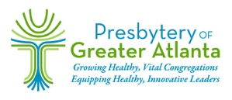
Presbytery of Greater Atlanta
Presbytery Partnership/Affiliated Organization —Application/Annual Report
Presbytery Partnership - consist of individuals and/or congregations working together to achieve a common mission within the Presbytery of Greater Atlanta.
Affiliated Organization - any organization not under the authority of PGA (endorsed by PGA to work with its member congregations).

Name of the Partnership/Affiliated Organization:

Mission Statement:

What benefit do you derive from being a Presbytery Partner?

Primary Contact (name/phone/email)

Secondary contact (name/phone/email)

Website and/or Facebook page specifics (if applicable)

List of member churches (If applicable)
Congregation Contact Person Email & Phone

Is this a 501 (c)(3) organization? If so, attach a copy of letter of incorporation.

Please send completed application and attachments to Partnership Liaison – Rev. Beverly Markham beverly@alpharettapres.com.

